Introduction

Although the Jenkins approach solved perfectly the requirement I would like to also provide a more sophisticated strategy, by using the “OpsWorks” service as a deployment tool which is provided by Amazon Web Services. OpsWorks uses Chef as source configuration, that means our deployment can be automated using scripts (cookbooks/recipes and another resources).

There are several advantages of using OpsWorks, more then the ones Jenkins offers. We could integrate other services in AWS along OpsWorks, like the ones which provides “high availability” to our applications: Elastic Load Balancers and Auto-scaling groups, just to mention a few.

So, let's enhance our “Strategy 1” design.

Deployment Strategy using Jenkins + AWS (OpsWorks)
I will integrate the following tools to our Jenkins design:
  - AWS OpsWorks: is an automated deployment tool offered by AWS; this uses the source configuration tool Chef. This allows to create our cookbooks/recipes to have our instances with the configuration we desire and also we can interact with these to make the deployment we need.

Deployment Diagram

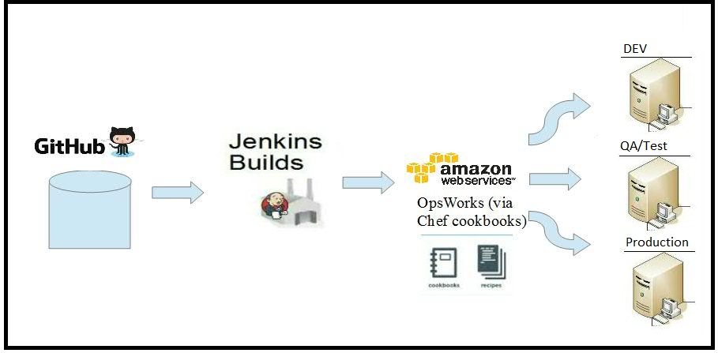

Information
- Github repository, https://github.com/artujose/com.test.app.git
- Github repository, to keep our Chef Cookbooks, https://github.com/artujose/chef_cookbooks
- Jenkins server (private), hosted in http://vmwsco1091.hursley.ibm.com:8080/.
- VMs provisioned by a private Cloud Service (Amazon Web Services)

NOTE: Instead of deployment the jar files directly into a server, we'll push the build output (jar files) back to GitHub by using “Git Publisher” plugin.

Creating the OpsWorks environment to make the deployment

- Create the “Stack” pointing to the right Git repository, where our Java Application jar was deployed, via Jenkins.

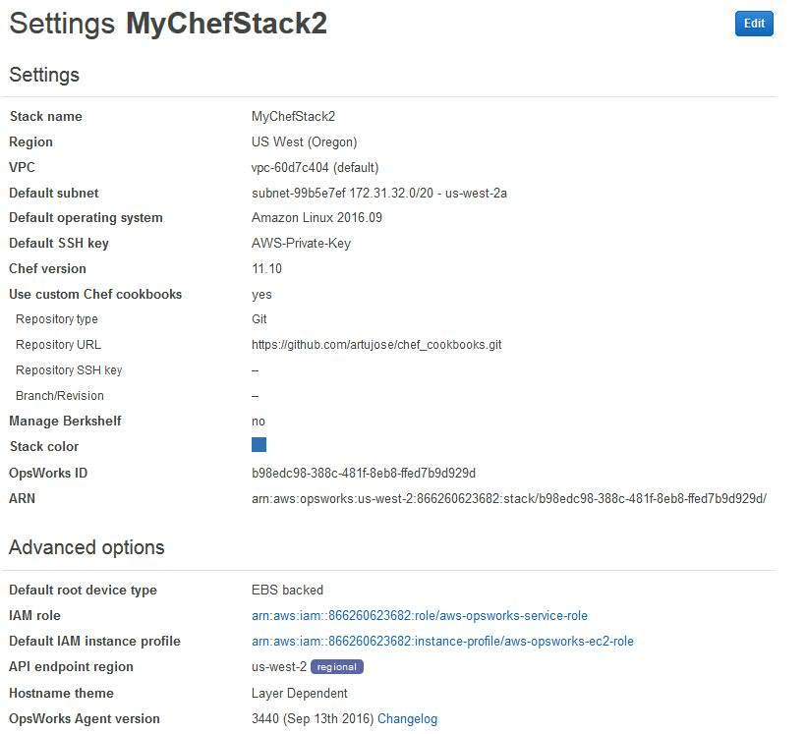
- Create a “Layer” specifying the cookbook and recipes we create to configure the deployment. Notice I have my cookbook in a git repository as well.
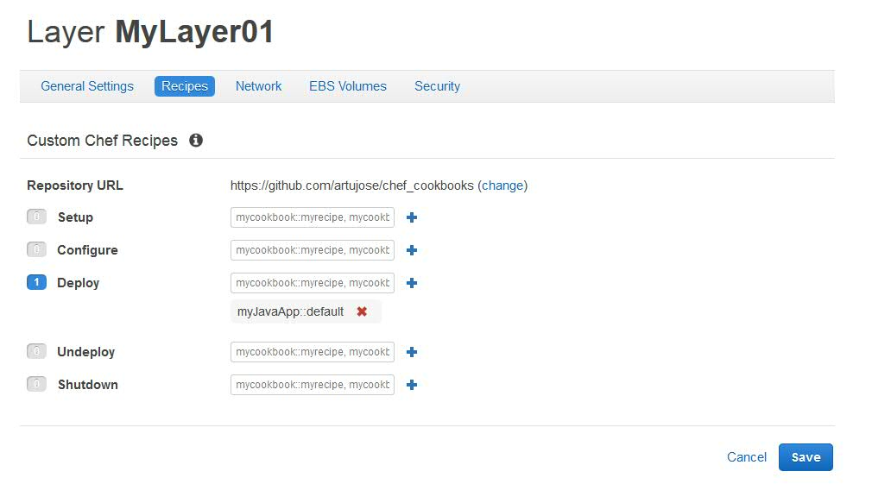

- Create an “Application”
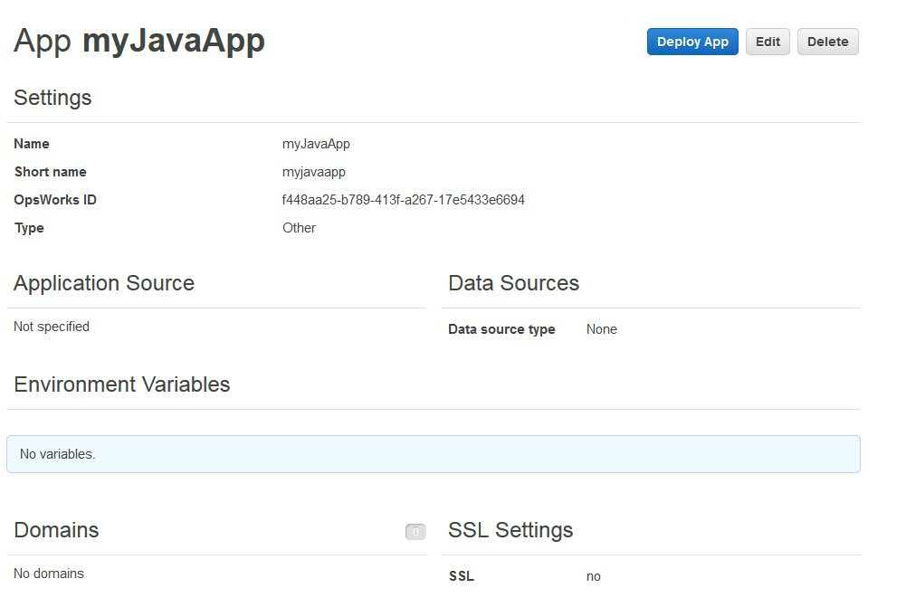

- Execute “Deploy” action

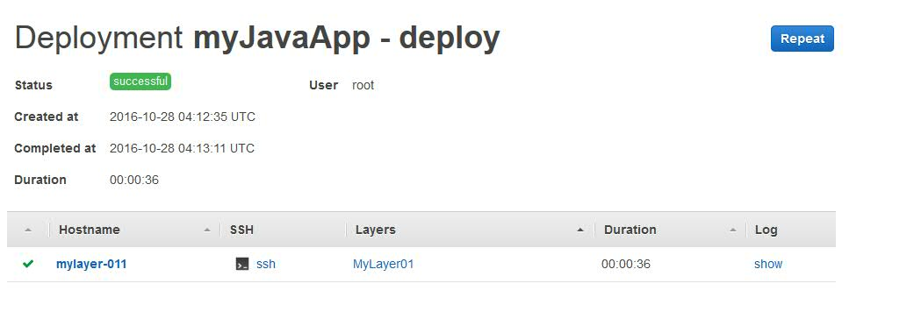

As you can see in this log file, the recipe was executed successfully:

[2016-10-28T04:13:09+00:00] INFO: HTTP Request Returned 404 Not Found: Object not found:
[2016-10-28T04:13:09+00:00] INFO: Loading cookbooks [myJavaApp@0.1.0]
[2016-10-28T04:13:09+00:00] INFO: Storing updated cookbooks/myJavaApp/Berksfile in the cache.
[2016-10-28T04:13:09+00:00] INFO: Storing updated cookbooks/myJavaApp/recipes/deploy.rb in the cache.
[2016-10-28T04:13:09+00:00] INFO: Storing updated cookbooks/myJavaApp/recipes/bad_default.rb in the cache.
[2016-10-28T04:13:09+00:00] INFO: Storing updated cookbooks/myJavaApp/.gitignore in the cache.
[2016-10-28T04:13:09+00:00] INFO: Storing updated cookbooks/myJavaApp/templates/default/myJavaApp_script.erb in the cache.
[2016-10-28T04:13:09+00:00] INFO: Storing updated cookbooks/myJavaApp/recipes/default.rb in the cache.
[2016-10-28T04:13:09+00:00] INFO: Storing updated cookbooks/myJavaApp/templates/myJavaApp.erb in the cache.
[2016-10-28T04:13:09+00:00] INFO: Storing updated cookbooks/myJavaApp/attributes/default.rb in the cache.
[2016-10-28T04:13:09+00:00] INFO: Storing updated cookbooks/myJavaApp/README.md in the cache.
[2016-10-28T04:13:09+00:00] INFO: Storing updated cookbooks/myJavaApp/metadata.rb in the cache.
[2016-10-28T04:13:09+00:00] INFO: Storing updated cookbooks/myJavaApp/.kitchen.yml in the cache.
[2016-10-28T04:13:09+00:00] INFO: Processing remote_file[/var/chef/runs/df3adb8d-68b8-466b-a5e5-c81ec5a0c1b6/local-mode-cache/cache/myJavaApp.jar] action create (myJavaApp::default line 9)
[2016-10-28T04:13:09+00:00] INFO: remote_file[/var/chef/runs/df3adb8d-68b8-466b-a5e5-c81ec5a0c1b6/local-mode-cache/cache/myJavaApp.jar] created file /var/chef/runs/df3adb8d-68b8-466b-a5e5-c81ec5a0c1b6/local-mode-cache/cache/myJavaApp.jar
[2016-10-28T04:13:09+00:00] INFO: remote_file[/var/chef/runs/df3adb8d-68b8-466b-a5e5-c81ec5a0c1b6/local-mode-cache/cache/myJavaApp.jar] updated file contents /var/chef/runs/df3adb8d-68b8-466b-a5e5-c81ec5a0c1b6/local-mode-cache/cache/myJavaApp.jar
[2016-10-28T04:13:09+00:00] INFO: remote_file[/var/chef/runs/df3adb8d-68b8-466b-a5e5-c81ec5a0c1b6/local-mode-cache/cache/myJavaApp.jar] mode changed to 644
[2016-10-28T04:13:09+00:00] INFO: Processing bash[run_jar] action run (myJavaApp::default line 14)
[2016-10-28T04:13:09+00:00] INFO: bash[run_jar] ran successfully
[2016-10-28T04:13:09+00:00] INFO: HTTP Request Returned 404 Not Found: Object not found: chefzero://localhost:8889/nodes/mylayer-011
[2016-10-28T04:13:09+00:00] INFO: Chef Run complete in 0.555954571 seconds
[2016-10-28T04:13:09+00:00] INFO: Running report handlers
[2016-10-28T04:13:09+00:00] INFO: Report handlers complete

Estimated time to solve it:
6 hrs

